**Day 3 Lab Assignments**

**Please do these assignments:**

1. Create a new page that has a textbox, and alert the code of key pressed on a textbox, and which mouse button clicked on it.
2. On the same page, Make a button (Start clock), that showing alert saying “Clock Started” and displays clock with current time in local format (time only without date) in a div updated every second.
   1. Handle the onclick event of the (start clock) button using JavaScript (Not in the input tag).
   2. Stop the clock when user clicks (alt + w) letter, and show alert saying “Clock stopped”.
3. Create a page that contains 3 images, and use JavaScript Code (not in HTML tag) to handle onclick event on all of them, to increase a counter when each image is clicked.
   1. Use addEventListner to add new handler for the onclick event listener, to alert the score (the value of the counter), when any image of them clicked.
      1. What’s the difference between handling the event using addEventListner() and other methods?
      2. Will addEventListner() will overwrite the other handler function attached to that button before?
      3. How does addEventListner() handles the event bubbling in better way?
   2. After 3 seconds (Use setTimeOut), use removeEventListner to remove the last event handler onclick that alerts the user score, and instead of it add new handler (Using addEventListner), that shows new alert saying “Game Over”.
4. Create a login form that redirect to another page when user submit the form, and put in this form textbox (user name) and password field (password) [textboxes must have name attribute] and button (login). User name text has default text “Enter your user name here”, when user clicks login he will be redirected to another page (the page given in the form action), use get method and on the other page get the user name (from the browser URL) and write on the page welcome + User Name in bold and big font letters.
5. Make a link that on its onClick event opens new advertising window after 3 seconds, and write long paragraphs on it. Also, make another link that closes this page. (Note that the browser may block the opening of the new window; make sure that you allow this page to open popups in your browser).
6. On registration form you make I Day.2, make a check box and label next to it “I agree to Terms and conditions” (Use label for this text), and make the label as a link that when clicked opens new page (html Page that you should create and put it in the same folder with the assignment) that contains long text and to be self-scrolling vertically (scrolls vertically automatically every half second).
7. On the same registration page, make the textbox of first name that accepts alphabetic characters only and don't accept numbers to be written on it (check for key code in keydown event, and use preventDefault).

**Bonus assignments:**

1. In assignment (2) stop the clock when user press (w) instead of (alt+w).
   1. Cancel event Bubbling on the page, so on assignment No.2, if the user presses (w) letter in the textbox (the cursor is in the textbox), it alerts the key code only, but don’t stop the clock, and stops only if press (w) letter on the document (when the cursor isn’t in the textbox).
2. Make a style to the links (in assignment No.5) to be like rounded button as the following:



1. In assignment No.6, handle that when the scroll reaches to the end of page, close the page.
2. Style your login page in Assignment (5), like the following:

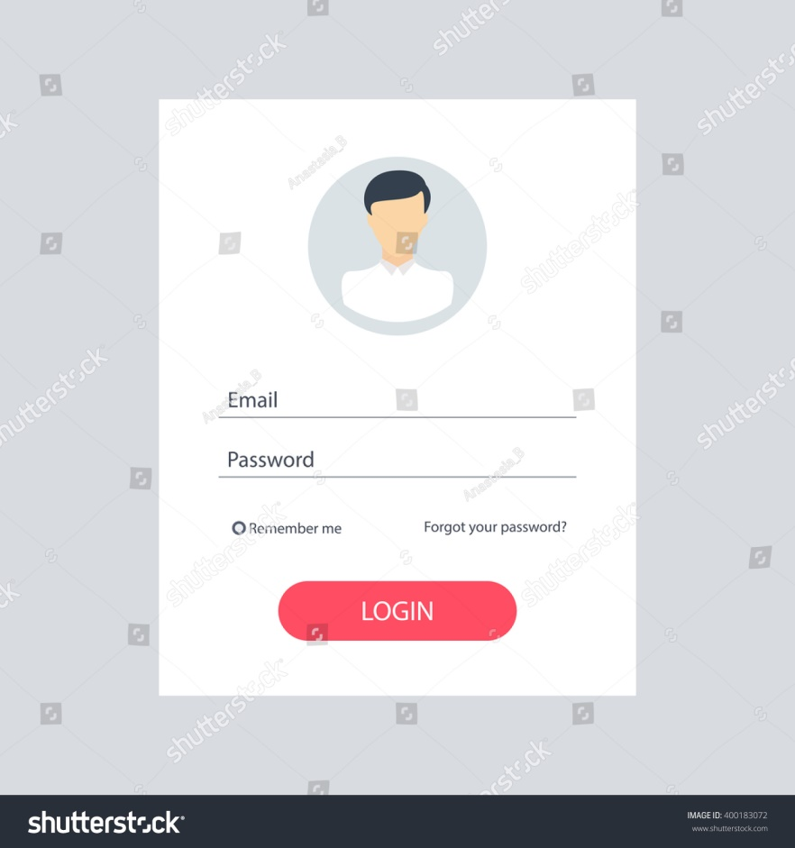

1. Make a page with scrollspy like the following demo: <https://www.w3schools.com/bootstrap/tryit.asp?filename=trybs_scrollspy&stacked=h> (WITHOUT using bootstrap, just use JS code).
2. Disable right click (only right click NOT left click) on your photo gallery page (make any page that has some images) to prevent anyone from saving your pictures.
3. Make masked textbox that accepts letters only (Not accept numbers).
4. Make an account on (<https://codepen.io>), and upload you previous 2 assignments to it.
5. Make a page that’s displaying google map, and drop down list containing countries, and when user select a country, change the google map to display this country.
   1. Make the google map when page loads display your current location (use geolocation object).
6. In Assignment No.4 (that opens new adv. window), make countdown until the page opened (3….2…1) next to open links.
7. Merge Assignments No. 4,5 to make the new advertising window that will open after 5 seconds, is scrollable automatically (without writing any code the new adv. window, make al code in the basic window)
8. Make a countdown timer for your graduation date, that calculates months, days, hours, minutes and seconds remaining for your graduation, and update the counter every second.
9. Make the home page when unloaded [put link to another page, don't close the page from the browser] show alert saying “Thanks for Visiting My Website” (search for the suitable event, and handle the event using JS, not in HTML tags).

**<Script>document.write(“Thank YOU”) </Script>**